Plagiarism report for “Quality of Care on Chronic Disease Management” document

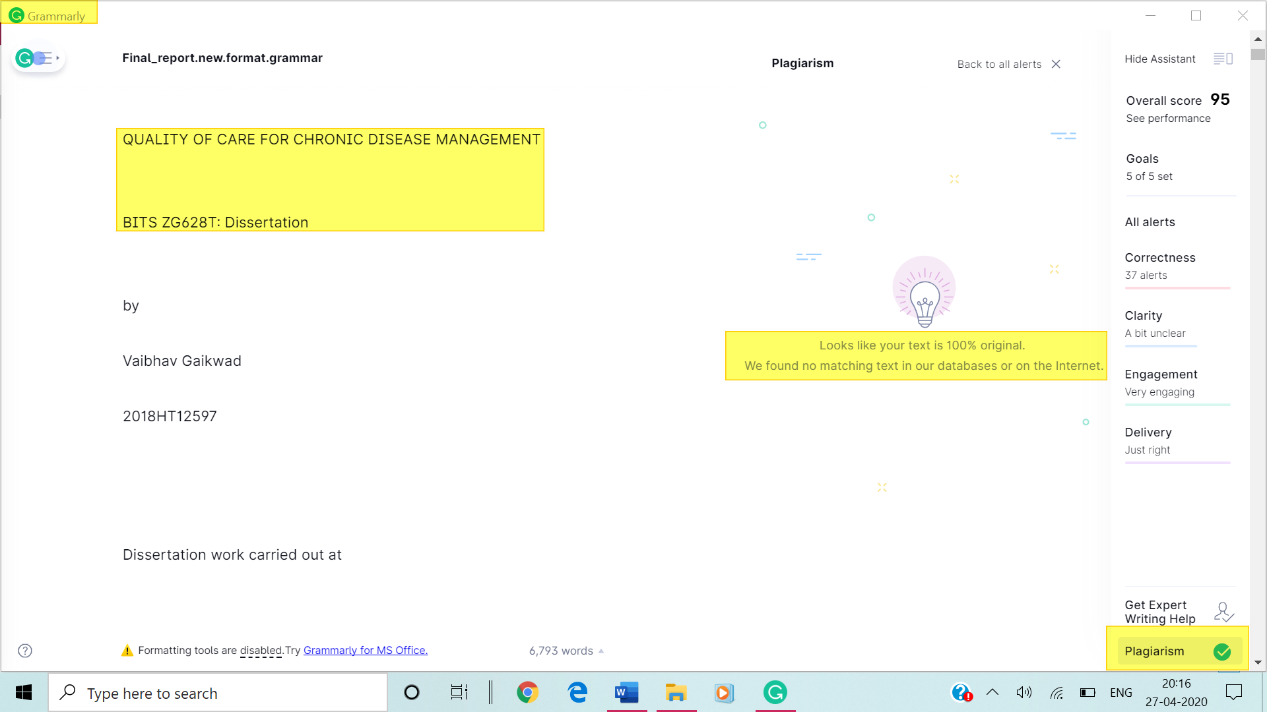

The check was done using Grammarly.com subscription and the results indicated 0% plagiarism. This was done after completing the final report and submitting it on 27th April 2020.

Vaibhav Gaikwad - 2018HT12597